COUNT ON US
PRIMARY CHALLENGE
PRIMARY CHALLENGE

IN-SCHOOL TOURNAMENT HANDBOOK 2022

RUNNING AN IN-SCHOOL TOURNAMENT

Why run an in-school tournament?

The Count on Us Primary Challenge is designed to excite and challenge all pupils in Years 4 and 5 in maths.
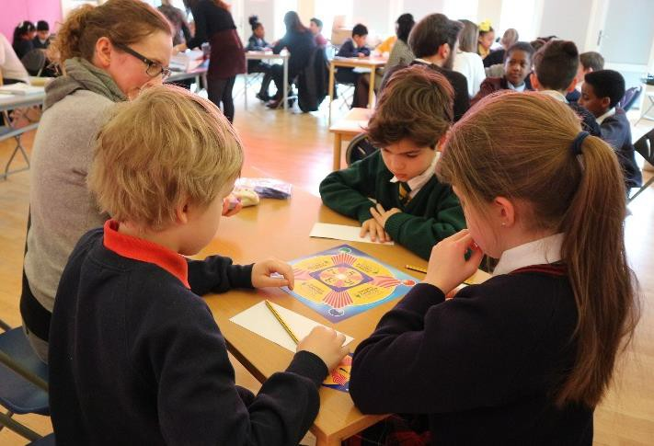
Once you’ve used the Primary Challenge activities in class and/or in clubs and your pupils have completed their Pupil Activity Book, it’s time to run a tournament in your school.

This will help you to choose the three pupils to represent your school in the Count on Us Challenge Heats.

When you choose your team, you will need to consider which pupils work well together. Have you made sure you have covered the range of skills needed and chosen pupils who shine at these?

Don’t forget that your team MUST be:
- a mixed gender team (no all boy or all girl teams)
- Year 4 and/or Year 5 (they can be all from one year group or mixed)
- new to the Challenge! Use your experienced pupils from previous years to help you run your clubs.

To make your tournament even more exciting, why not reach out to local Primary Challenge schools to make the tournament even bigger! If your school is part of a federation, this is a great time to get together and plan a joint tournament.

Benefits of running an in-school tournament:

- Pupils get the chance to practise the activities in a competition setting before the Heats.

- You can determine who should represent your school at the Heats in a fair way – you might be surprised by who stands out!

- You can invite parents to come along and watch – or even to compete against their children!

- It’s a great opportunity for personal development – organising an event and making it as fun as possible.

- There is the chance to build community links by reaching out to other schools locally and collaborating with them.

- It will provide you with positive maths stories for your newsletters.

- It’s lots of fun! Pupils love taking part.

WHAT YOU NEED, TO SET UP A TOURNAMENT

Choose a suitable hall/large space – you can even run it in your classroom!

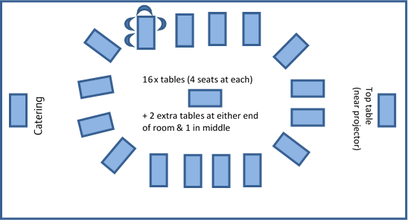
This is an example layout – and is how we set out the room for the in-person Heats.
Primary Challenge Heats Layout

Make sure you have enough tables to group three pupils and one adult referee/older pupil per table.

This layout is particularly helpful during the 24® Game round, when pupils move round tables. However, it may not be possible due to the size/shape of your space. Be creative!

You may prefer to use larger tables and have two groups of three pupils at either end - see picture below.

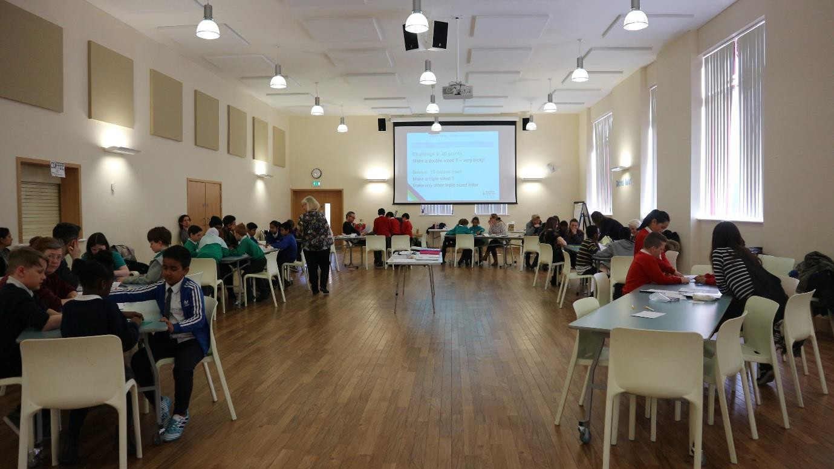
Taken at the Regional Heats 2018!

If you are using longer tables and want to follow the Tournament layout as in the Heats, remember you need an adult per team of three pupils/table.
If you don’t have enough adults, you may want to consider joining the tables together, or having one adult per every three or four teams of three.

Teacher/Adult

You will also need:
- A chair per pupil (+ for every adult who is helping to referee)
- Pencils/pens for each pupil + referee
- Projector & screen
- Stopwatch/timer
- Hooter/whistle
- Printed copies of activity sheets and scoresheets

TOURNAMENT ROUNDS: PRESENTATION AND PRINTING

You may want to create your own activities for each of the three rounds. However, we have already prepared an in-school Tournament presentation, with activities, which is ready for you to use.

To find it, go to the Resource Area on the Mayor’s Fund for London website and download the ‘2022 In-school Tournament Presentation and Printing files’.

Reminder
password for 2021-22 Count on Us Primary Challenge Resource Area: LOVELACE1852
The presentation is a PowerPoint file which you can show on a whiteboard. Teacher notes accompany each of the activities. You may wish to print these for reference during the tournament.

or

Why not create your own tournament activities!

You will need to design:

- Three 5 x 4 Domino Grids (choose three from the workbook, training or online)
- Three T Shape pictures
- Bonus points: Have additional Domino grids and T Shape pictures ready for the speedy pupils!
- Create your own codebreaking/problem-solving scenario!
- Remember to use Simon Singh’s Black Chamber website to help you: https://www.simonsingh.net/The_Black_Chamber/caesar.html.
- Encipher some clues and create a maths problem that the pupils need to find the answer to.

Scorecards and Team scoresheets
These can all be found in the ‘2022 In-school Tournament Presentation and Printing files’ section of the Resource Area.

You will need to print out:
- Team scoresheets for the whole tournament. One per table, for the referee.
- 24® Game scorecards – one set of A, B, C cards per table.
- Codebreaking Pupil Pack – one per table.
- Tournament scoresheet (can also be filled in electronically) for the Tournament Lead (the teacher running the event – TL)

Additional optional printing:
If you do not have access to a whiteboard in the tournament room, Round 1 will require a printed set of Domino grids and T Shape pictures, which the referee will give out to their table, as required.

Equipment to set out on each table, as needed:
- 1 x Domino set
- 1 x T Shape puzzle set
- 1 x 24 Game pack* + pupil scoresheets
- 1 x Codebreaking pupil pack

*if you don’t have enough, split the packs. Just try to ensure that each team has the same number of 1, 2 and 3 dot cards, for fairness.

Staffing/Helpers:
- You will need assistance to help set up the hall (ask your pupils to volunteer!)
- One staff member to host the tournament: Tournament Lead (introduces rounds, clarifies rules and acts as timekeeper).
- One staff member/adult/older pupil helper to referee each team of three.
- It may be easier to assign a few teams to each available staff member. For shape and codebreaking this will not make much difference to scoring; for 24® Game there may be some extent of pupils scoring themselves (and trusting each other to be correct with their solutions!)
- Another option is that all pupils are given scorecards and have to keep track of their own scores, and these are marked and tallied up afterwards instead of being marked alongside the rounds.
- Parents/adult/pupil cheerleaders (optional but a great addition!)
- One adult/older pupil looking after refreshments (optional).

TOURNAMENT TIMINGS (an example)

1.00pm | Welcome/Intro
1.15pm -  1.30pm | R1: Dominoes  (team activity) | 3 x Domino grids  3 minutes each
1.30pm -  1.45pm | R1: T Shapes  (team activity) | 3 x T Shape puzzles  3 minutes each
1.45pm -  2.10pm | R2: 24 Game  (Individual activity) | 3 x 24 Game rounds  4 minutes each  (Allow time for pupils to change tables)
2.10pm -  2.20pm | Break
2.20pm -  2.50pm | R3: Code Breaking  (team activity) | 1 activity  15-20 minutes (dependent on level of difficulty)
2.50pm -  3.00pm | Scoring, results & celebration!

This example shows how you can organise a 1.5 - 2 hours tournament. The timings allow for introductions, explanations and scoring.

If you have less time, you could:
- Split the tournament over two days.
- Do the scoring for Codebreaking after the event and announce results later.

TOURNAMENT LOGISTICS ON THE DAY
See Teacher Guide for full activity instructions.
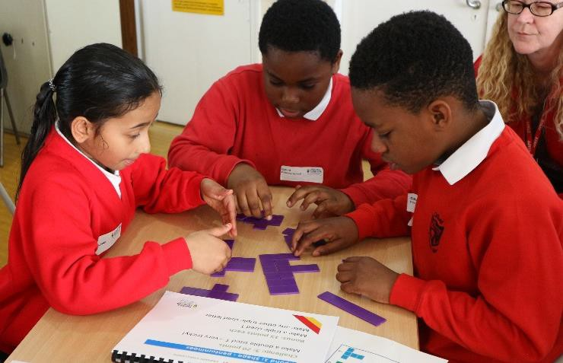
To start:
Pupils should sit in their teams
of three (team sizes may be bigger
depending on the number of pupils competing) with a table referee.
Each team fill out its name on the team scorecard and their individual names on the 24 Game scorecards.

Round 1: Pattern and Problem Solving
- Domino and T Shape sets should be out on tables (but ask pupils to put hands over them while you are introducing the activity).
- Tournament Leader (TL) explains Dominoes activity.
- TL either shows 1st Domino grid on large screen or tells table referee (TR) to give out 1st Grid.
- In teams, pupils try to solve the puzzle.
- After three minutes, the TL blows a whistle.
- TR quickly awards marks for completion (or not) on team scoresheet.
- TL either changes the picture on the screen or tells TR to give out 2nd grid.
- Repeat for 3rd grid.
- Put Domino set back in bags, then move on to T Shapes.
- Repeat above for T Shapes.
- Have bonus puzzles ready for speedy teams! (Note: as soon as the three minutes are up, all bonus tasks must also stop until the team next has time).

Timings
- Three minutes per puzzle

Scoring
- Points are awarded for each completed puzzle within the allocated time.
- Each team will receive either 15 points per puzzle, or nothing.
- Award extra points for any bonus puzzles completed – but these can only be attempted if they have completed the main puzzle and have time to spare.

Round 2: 24® Game

Team members are appointed A, B & C (this only works if your pupils are in teams of multiples of three. If you cannot do this, try to swap pupils around between rounds so they play different people).

IMPORTANT:
Before the tournament, make sure that all players and table referees (TR) understand how this round is played. This is explained in detail in the Teacher Guide.

Each team member will play two pupils from two other schools/teams. Therefore, the movement of pupils is important to get right! See Teacher Guide for detail.

- All ‘A’ players should move one table clockwise before each round (they will end up sitting in another ‘A’ players’ seat).
- All ‘C’ players should move one table anti-clockwise at the end of each round (they will end up sitting in another ‘C’ players’ seat).
- ‘B’ players do not move.
- TL reminds players of the rules and makes sure table referees understand.
- Pupils play the 24® Game competitively for three minutes.
- After 3 minutes, scores should be added up and verified by adults (see below).
- Players ‘A’ and ‘C’ then move around one seat in their respective directions again, so they are competing against two new people.
- Pupils play another three minute round.
- Repeat player rotations and play one more round.

Scoring
- Each pupil has an individual scorecard for this round, which they need to take with them when they move seats.
- Points for each round are calculated by adding the number of spots in the corners of the cards they claimed and won (see Teacher Guide for rules).
- After this round, all pupils move back to their original teams and add their scores up together.

Round 3: Codebreaking

Set up
- Pupils sit at their original team tables, with a different TR.
- There is a lot of flexibility and creativity to be had with this round – you can get your pupils running all over the hall to collect clues for instance!
- TL introduces the activity, making sure that each team has the required information and answer sheets.
- TL blows whistle to start (and after 20 minutes to end).

Timings
- We recommend around 20 minutes for this round – unless you have designed your own shorter codebreaking activity.

Scoring
Points are awarded for:
- each enciphered word or phrase correctly deciphered
- solving the overall problem
If you are using last year’s Heats activity the scorecard is quite straightforward and you can use this for inspiration to create your own if you’d like.

Outcome:
The team with the highest number of points overall wins.
- Keep a track of how individual pupils did in 24® Game to help choose your Count on Us school team.
- Remember to look out for good team players, who can collaborate well.

Some additional ideas
- Hand out school tournament certificates in assembly.
- Make a display board with photos from your tournament.
- Write about the tournament in the school newsletter or local paper!
- Upload photos to Twitter and Tweet us @mayorsfund #PrimaryChallenge

Remember, this is just a guide to help you run a tournament similar to the Heats. Feel free to be creative and adapt the activities and rules to fit your school and your facilities. The most important thing is that your pupils enjoy themselves and feel empowered to have a go at the Count on Us Challenge!

NOTES PAGE:

