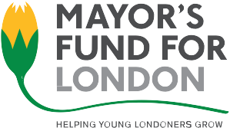

Please refer to the guidance notes before completing this application form
Please use black ink or typescript

Job details

Title of the post for which you are applying

Personal details
Forenames
Surname
Email address |  |  | Phone number

Selection arrangements
- Do you have any particular requirements regarding interview or other selection arrangements?

- Would you prefer to have a face-to-face interview or a virtual/video interview?

- Please specify any dates that you are unable to attend an interview for the role.

- Do you have a disability? *
- Yes
- No
- Prefer not to specify

We support disability as defined under the Equalities Act 2010 and the 'social definition' of disability.
- Please also indicate any periods of absence due to leave or other reasons N/A

- Which University do you currently attend?

Previous employment and other skills/experience/qualifications relevant to the role.

General experience and further information

Please use the space below to tell us how you meet the requirements for this role, as outlined in the person specification section of the job description. Please ensure you address both the technical requirements and behavioural competencies. (Please keep your response to a max of two-sides of A4).

In providing your evidence, please use examples of your past experience to demonstrate that you have the skills and experiences required for the role. You can use experience and knowledge gained from current and previous employment, voluntary work, leisure interests and any other activities you consider relevant to this position

Technical requirements/experience/ qualifications

Declaration – to be signed by applicant

I confirm that to the best of my knowledge the information I have provided on this application form is true and correct and that the information may be used for registration purposes under the Data Protection Act 1998.

I am returning this form electronically and unsigned I understand that I will be bound by the declaration when the Mayor’s Fund for London receives the electronic application.

Signed: Date:

Please return this form along with the Equal Opportunities form electronically to entrepreneur@london.gov.uk you will receive a delivery receipt within 24-hours of your submission. If you do not receive a receipt after 24-hours please contact us on 0207 983 4622.

