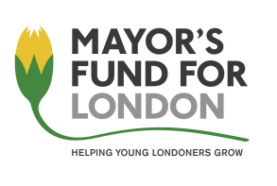
COUNT ON US
PRIMARY CHALLENGE 2020-2021

Teacher and Pupil Names

Please complete and return the form below by Wednesday 24th March to:
Bronwen Owen: bowen@mayorsfundforlondon.org

School Name:
Teacher name:
Additional Adult name:

Remember:
The team of 3 pupils must:
- be a mixed-gender team
- not have taken part in Count on Us Challenge in previous years.

Pupil Name | Year group | Gender (M/F)

.

